**Assignment No:-64**

Name:-Suryawanshi Sangramsingh Sambhaji

Batch: - Delta - DCA (Java) 2024 Date:-21/8/2024

1.Find the Missing Number:

Given an array containing n distinct numbers taken from 0, 1, 2, ..., n, find the one that is missing from the array.

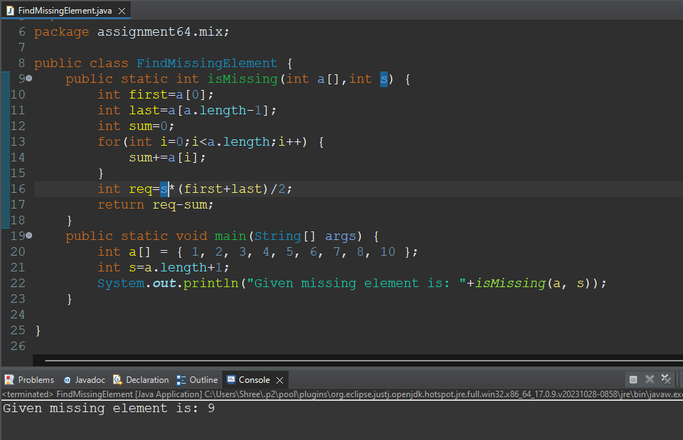

2.Find the Largest Palindrome Substring:

Given a string, write a program to find the largest palindrome substring in it.

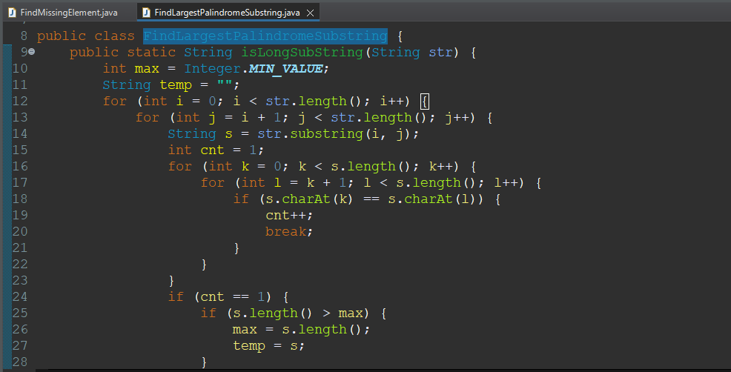

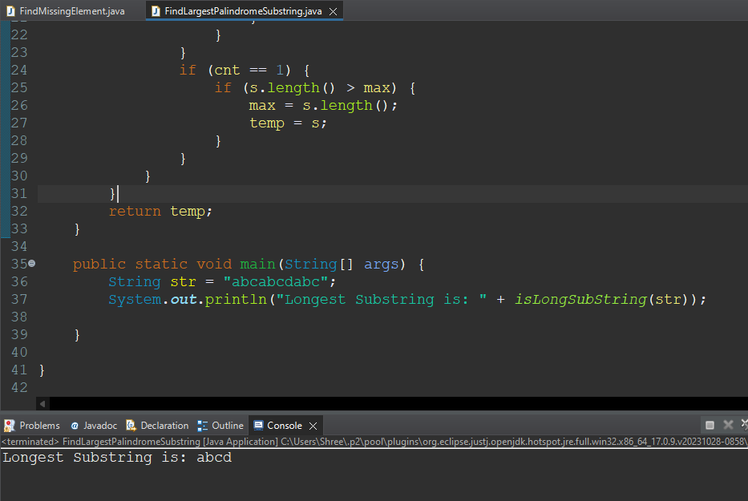

3.Anagram Checker:

Write a function to check if two given strings are anagrams of each other.

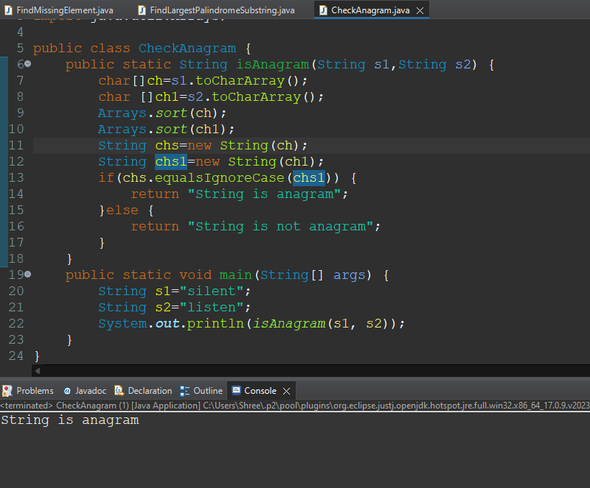

4.Matrix Rotation:

Given an n x n matrix, write a function to rotate the matrix by 90 degrees clockwise.

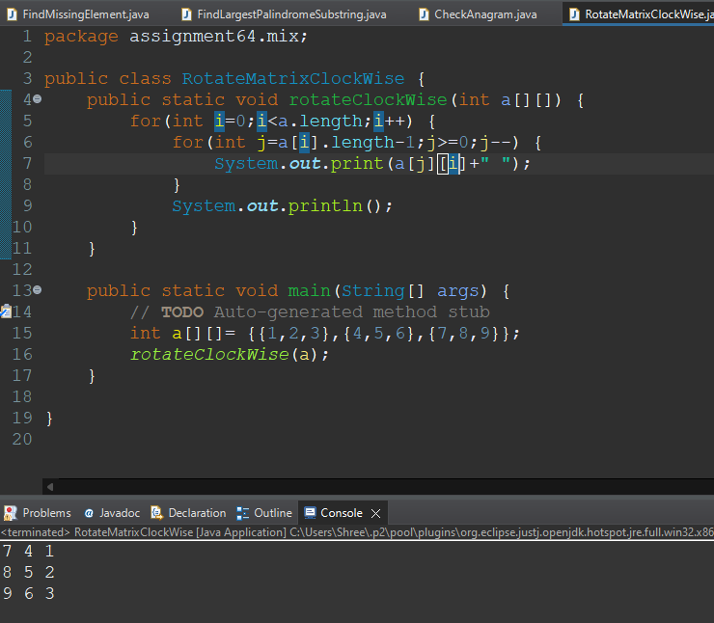

5.Sum of Digits in an Integer:

Write a program to find the sum of the digits in a given integer.

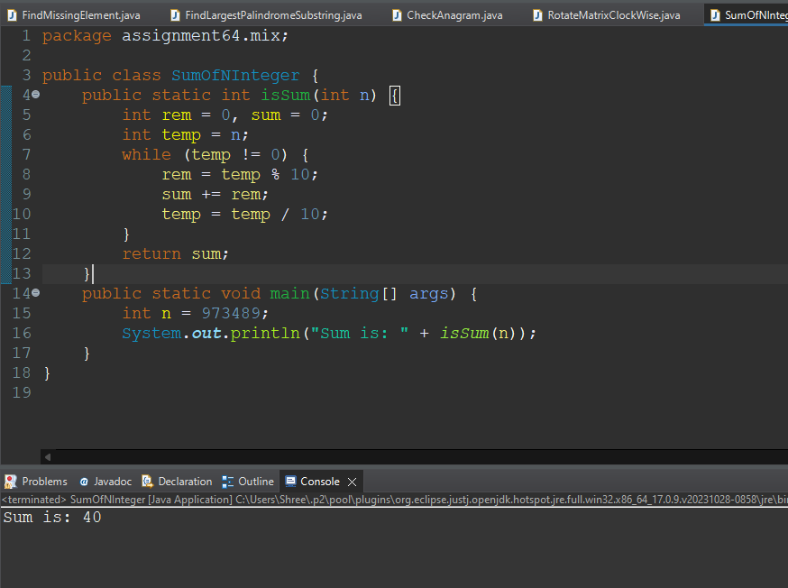

6.Find All Pairs with a Given Sum:

Given an array of integers, find all pairs of elements that sum up to a specific target number.

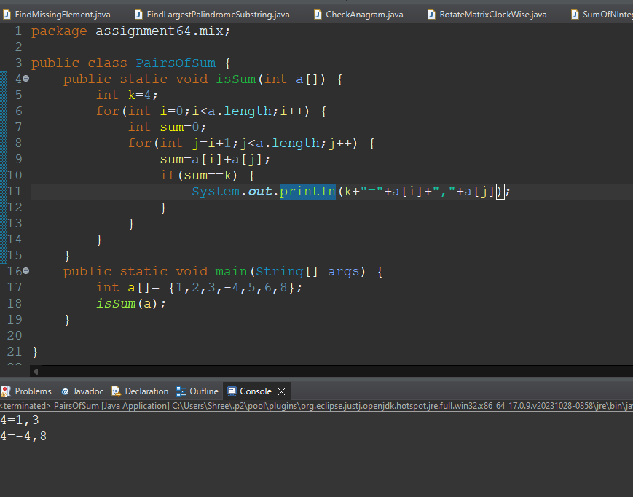

7.Merge Two Sorted Arrays:

Given two sorted arrays, write a function to merge them into a single sorted array.

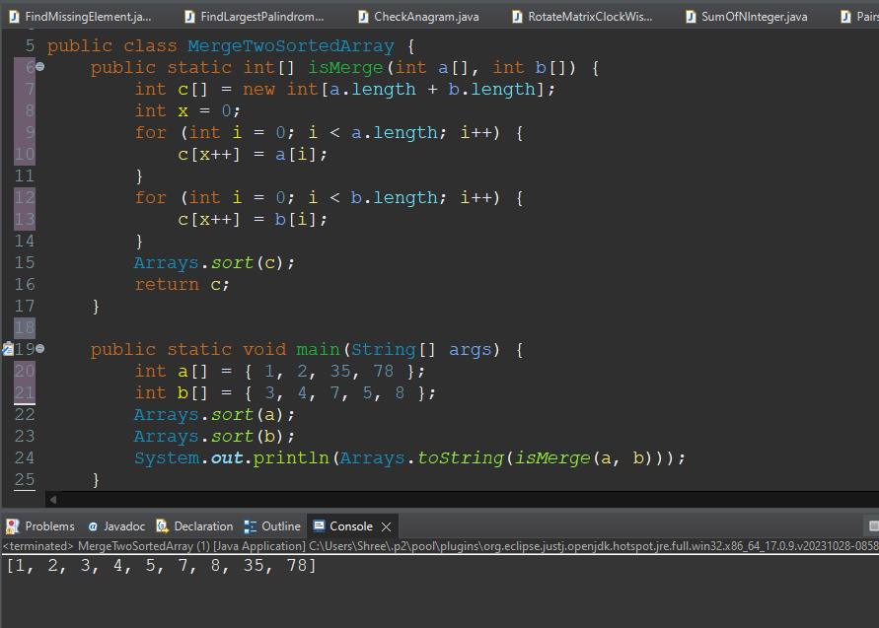

8.Fibonacci Series:

Write a program to generate the first n numbers in the Fibonacci series.

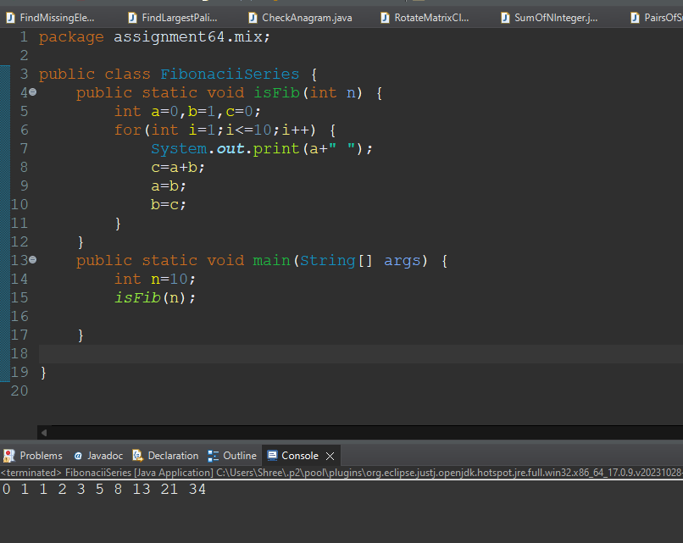

9.Check for Balanced Parentheses:

Write a function to check if a string containing parentheses is balanced.

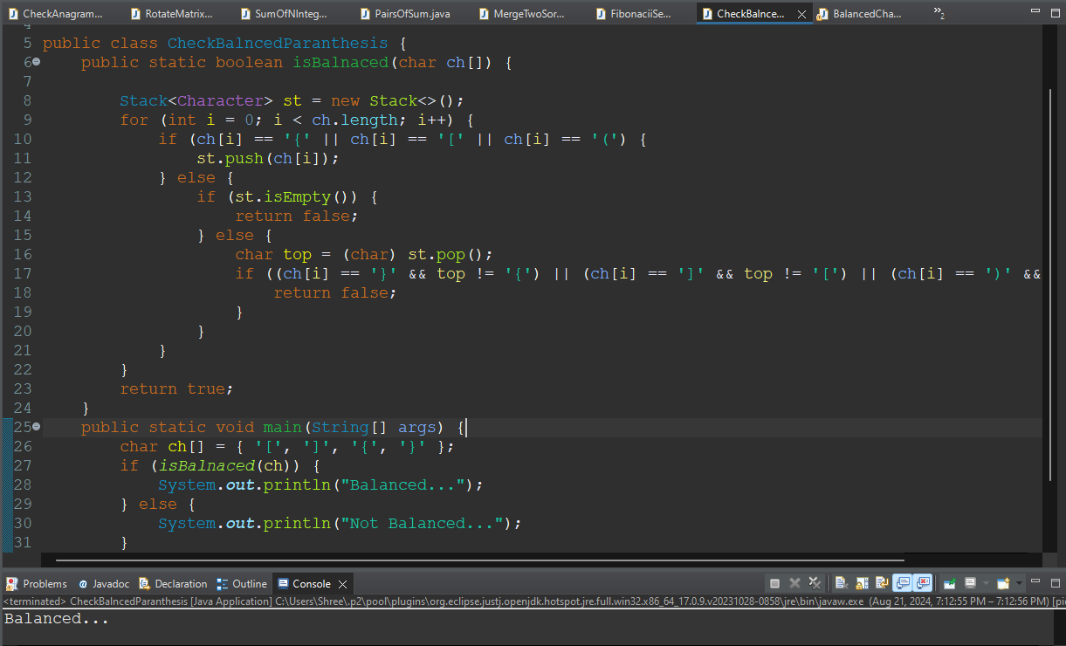

10.Find the Second Largest Element:

Given an array of integers, write a program to find the second largest element.

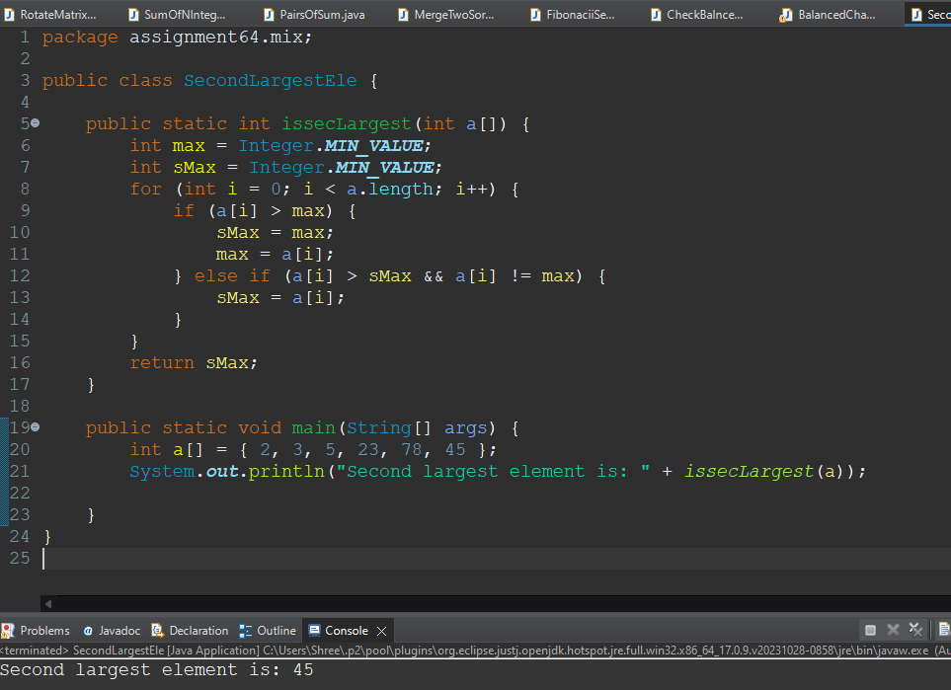

11.Reverse Words in a String:

Given a string, write a program to reverse the words within it.

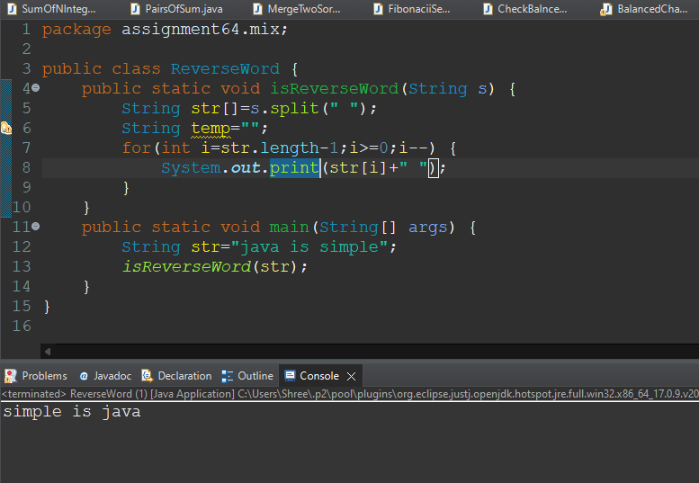

12.Longest Common Prefix:

Write a function to find the longest common prefix among a list of strings.

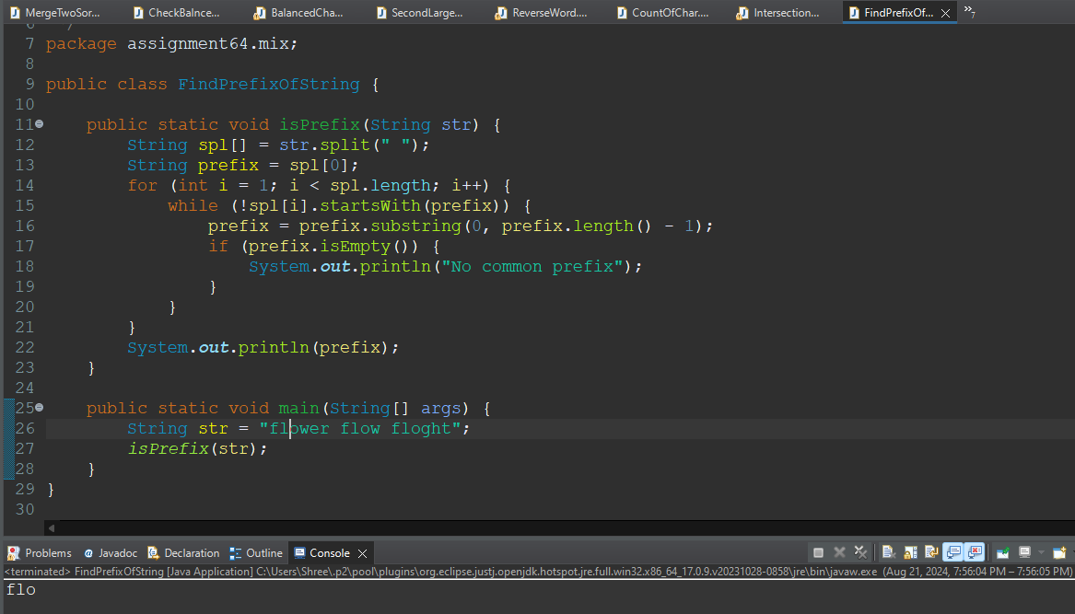

13.Count the Frequency of Characters in a String:

Write a program to count the frequency of each character in a given string.

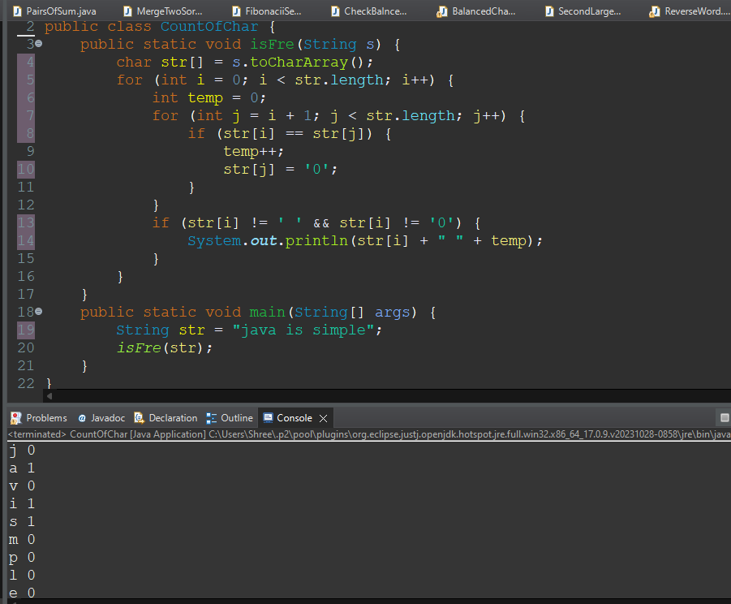

14.Find the Intersection of Two Arrays:

Given two arrays, write a function to find their intersection, i.e., elements that are present in both arrays.

